# Use Cases

**Select_course(course)**

Postconditions:

* Course is associated to student record
* Course is associated to schedule generator

**Select_section(section)**

Postconditions:

* Section is associated to student record
* Section is associated to schedule generator

**Manually Adding a Course: System Sequence Diagram**

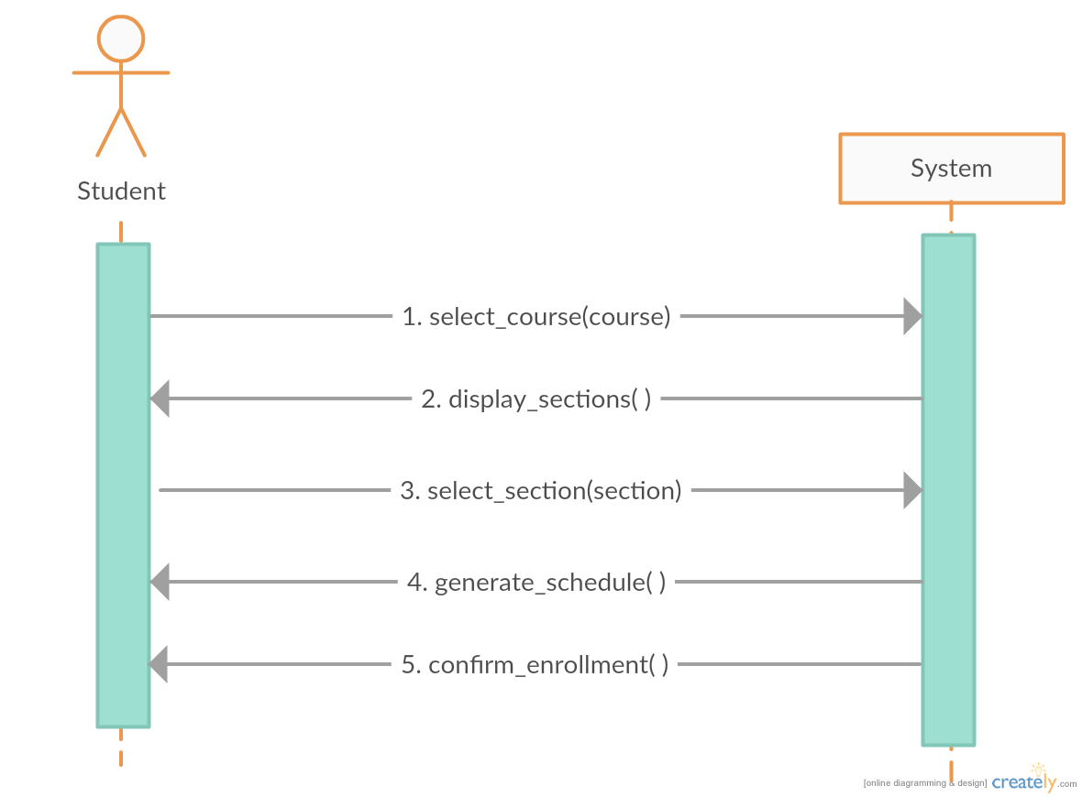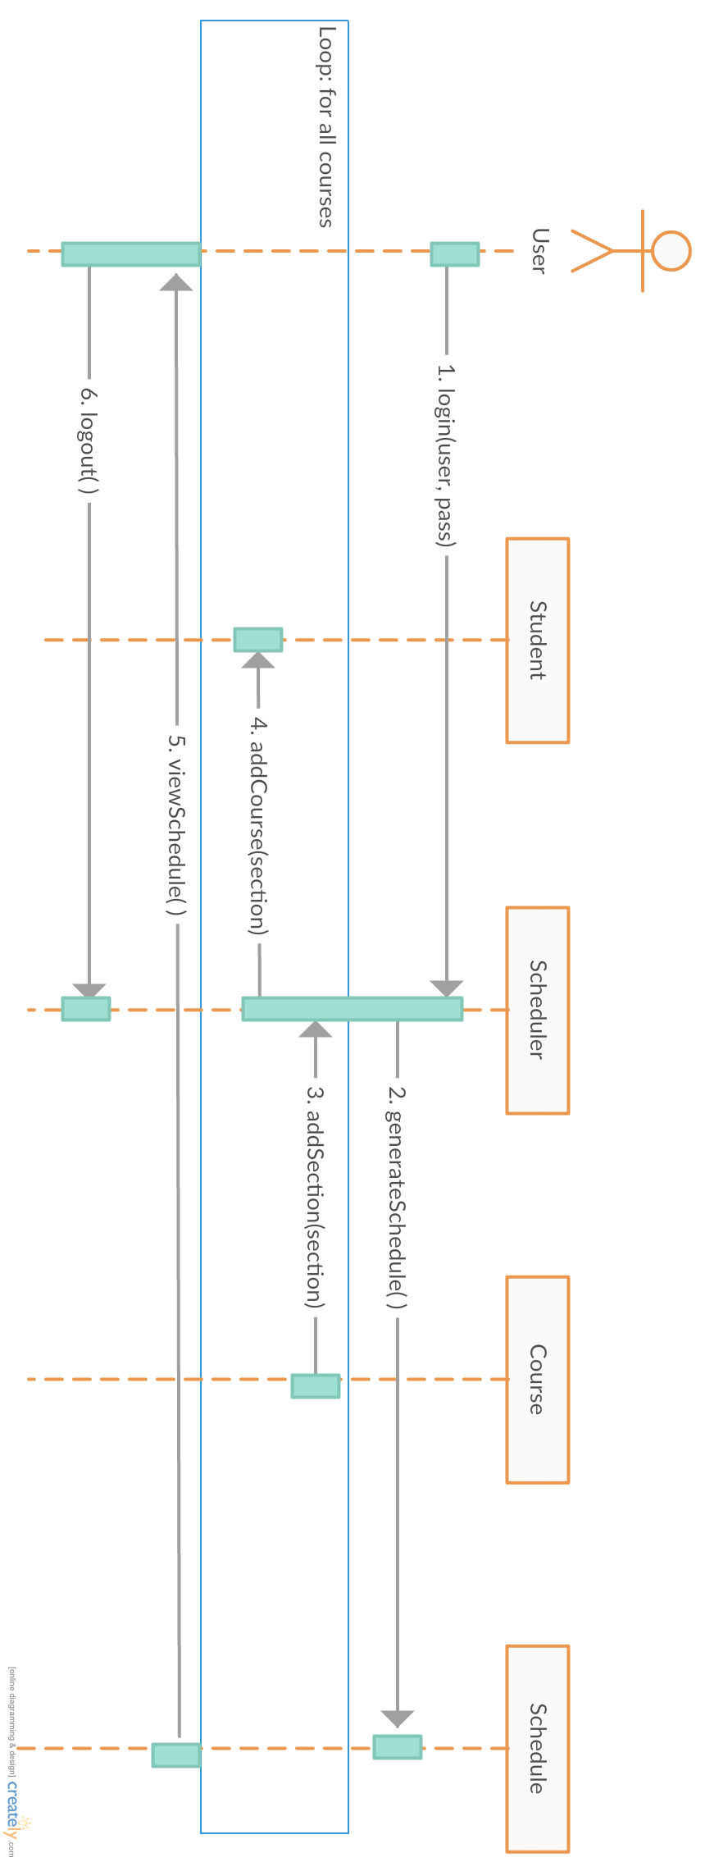

Auto generate:

The user first logs into the scheduler. Next, their schedule is generated using their student information. During this process, the courses and sections are obtained. These courses are then individually added to the student’s current course pool, along with the appropriate sections. When all the courses have been added, the resulting schedule is then displayed to the user. The user may then logout from the system.

Manually add:

The user first logs into the scheduler. They can then search for a course they want to be enrolled in. The course is found and its respective sections are obtained and displayed to the user. The user can then select a section and add it to their current schedule. If the chosen section could not be added, the user is sent back to select another section. After the course has successfully been added, the current schedule is displayed to the user. The user may then logout from the system.

